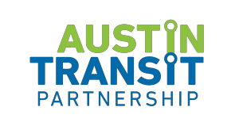

PROJECT CONNECT COMMUNITY ADVISORY COMMITTEE

The Community Advisory Committee will convene on
Thursday, May 11, 2023 | 5:00 PM - 7:00 PM
Austin Transit Partnership Office Board Room
203 Colorado St. | Austin, Texas, 78701

The presiding officer will be present at the above location and some members of the
Committee may participate by videoconference at
https://capmetro-org.zoom.us/webinar/register/WN_uL9sN9eEQc2VYctme7lyQQ

- Call to order
- Land Acknowledgment
- Public Comment
- Discussion Items
  - Austin Light Rail Implementation Plan Options
- Action Items
  - Austin Light Rail Implementation Recommendation
- Staff Updates
- TAC Delegate Reports
- Working Group Reports
- Future Meetings and Agenda Items
- Adjourn

ADA Compliance
Reasonable modifications and equal access to communications can be provided upon request with 24 hours’ notice. Please call (512) 484-3440 or email feedback@projectconnect.com
for more information.

Community Comment
To provide feedback virtually or in-person during committee meetings please email feedback@projectconnect.com at least 24 hours prior to the meeting.

###

